

**19th Annual Meeting**

**October 7 – 9, 2025**

**Vienna, Austria**



**Inland ENC Harmonization Group**

**19th Annual Meeting**

**October 7th – 9th 2025**

**Location: Federal Ministry of Innovation, Mobility and Infrastructure  
Meeting room 6 C 15  
Radetzkystraße 2  
1030 Vienna  
Austria**

**Lodging:** A block of rooms has been reserved in the hotel Ruby Sophie,   
<https://www.ruby-hotels.com/en/destinations/vienna/ruby-sofie>

Marxergasse 17

1030 Vienna

A reduced price of € 175 per night including breakfast is available with the code **BMI061025** until 6 August 2025.

BOOKING CONDITIONS

Rooms are available to guests on the day of arrival from 3 pm at the earliest and must be vacated by 11 am at the latest on the day of departure.

A room that has already been booked can be returned for free up to 5 days before arrival. Thereafter, a free return is no longer possible and the payment for the contractually agreed service, less any expenses saved, shall be due. The contract with the Guest, which is concluded via the booking on the website using the groupcode, is executed via the online booking process including payment with a valid credit card, which will be charged after the deadline for free cancellation has expired. The Guest will receive a final invoice by email after their departure.

The hotel is 900 m from the ministry (approximately 12 minutes to walk) and 400 m from the train and subway station Wien Mitte.

Of course there are also other hotels in the vicinity of the ministry that can be booked directly or via the various booking platforms.

**Local contact:** Bernd Birklhuber

E-mail: [bernd.birklhuber@bmimi.gv.at](mailto:liuli@wti.ac.cn)

Mobile phone: +43 664 8188909

**Transportation to the train and subway station Wien Mitte Landstraße from the airport Vienna (VIE)**

* City Airport Train (CAT) is a fast direct connection (16 minutes) without any intermediate stops running every 30 minutes. The price is € 14,90 for a one way ticket and € 24,90 for a return ticket. There are reduced prices for online tickets, but you can also by tickets in the arrival hall (green ticket maschines): [https://www.cityairporttrain.com/en/](https://www.cityairporttrain.com/en/%20)
* Train S7 is also a direct connection to Wien Mitte, but takes 25 minutes. The interval is also 30 minutes. The price for a one way ticket is € 4,90. Tickets can be bought online or at ticket machines at the train station at the airport:   
  <https://shop.oebbtickets.at/en/ticket?cref=oebb-header> (from “Flughafen Wien Bahnhof” to “Wien Mitte-Landstraße-Bahnhof (U)”)
* Of course there are also taxis available: <https://www.viennaairport.com/en/passengers/arrival__parking/taxis__limousines>

**From the train and subway station Wien Mitte Landstraße to the hotel Ruby Sophie**

Wien Mitte is not only a train and subway station, but also a shopping center and has several entrances.

* If you arrive with the CAT: take the escalator to ground level and go through the ticket and waiting area to the exit of the CAT area. Turn right and you can already see the exit Marxergasse.
* If you arrive with S7: there are several exits from the platform. Take the escalator or the stairs to Wien Mitte Landstraße and enter the shopping center. Leave the station Wien Mitte via the entrance Marxer Gasse.
* Turn right (east) and follow the Marxer Gasse for app. 400 m. The hotel Ruby Sophie is on the left side

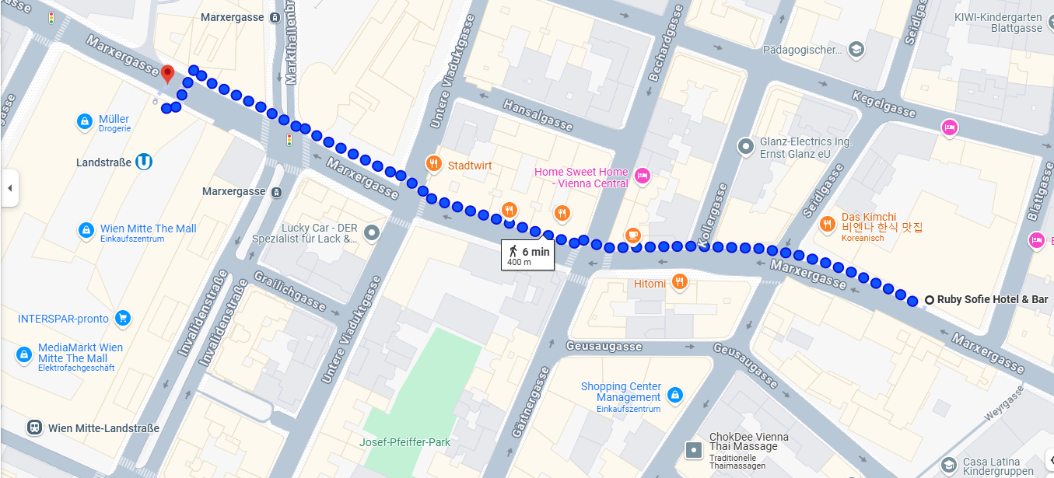

**From the train and subway station Wien Mitte Landstraße to the ministry**

Wien Mitte is not only a train and subway station, but also a shopping center and has several entrances.

* If you arrive with the CAT: take the escalator to ground level and go through the ticket and waiting area to the exit of the CAT area. Turn right and you can already see the exit Marxergasse.
* If you arrive with S7: there are several exits from the platform. Take the escalator or the stairs to Wien Mitte Landstraße and enter the shopping center. Leave the station Wien Mitte via the entrance Marxer Gasse.
* Turn right (east) on Marxer Gasse and turn left (north) on Hintere Zollamtstraße at the first crossing. Turn left (east) at the next crossing to Radetzkystraße. The entrance to the ministry is on the left side. You will have to show a proof of identity at the reception desk.

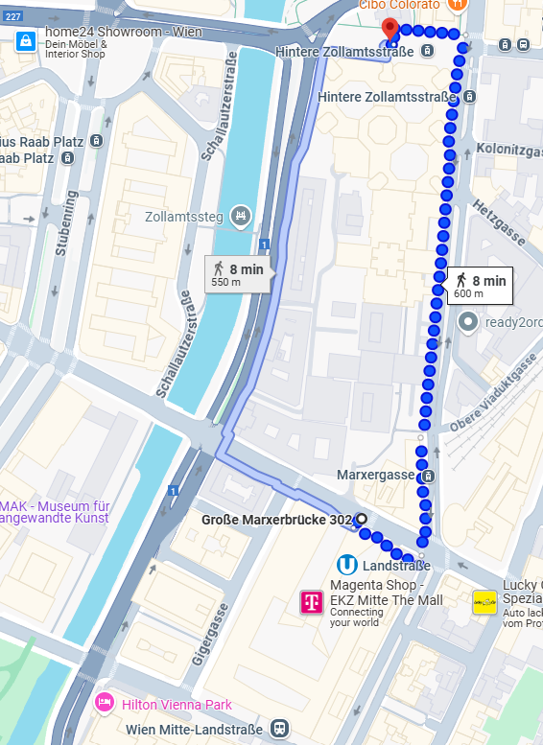

**From hotel Ruby Sophie to the ministry**

Turn right (west) when you leave the hotel. Follow the Marxer Gasse for 350 m and turn right (north) to Hintere Zollamtstraße. Turn left (east) at the next crossing to Radetzkystraße. The entrance to the ministry is on the left side. You will have to show a proof of identity at the reception desk.

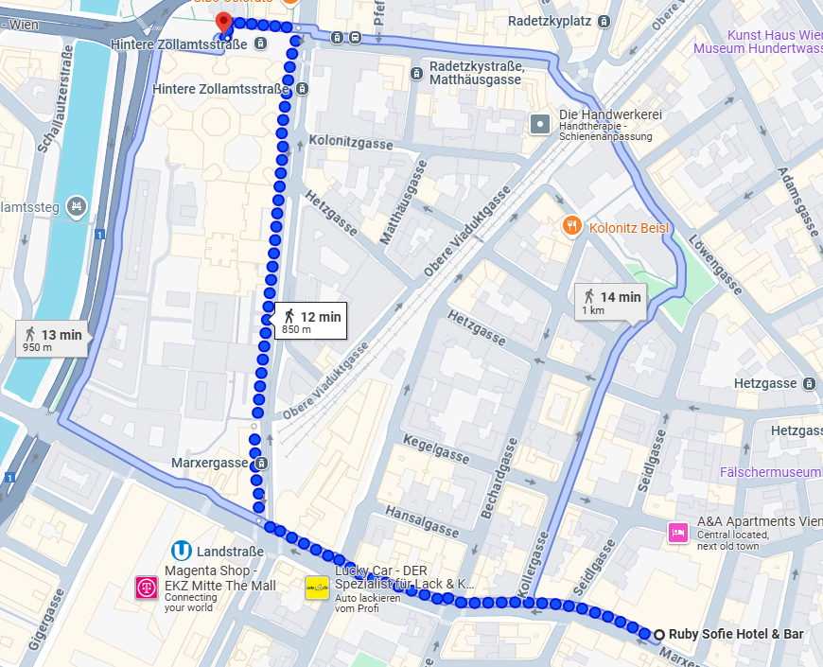

**Draft Agenda of the IEHG meeting**

Documents for the meeting are available at <https://github.com/IEHG/IEHG-Meeting-2025>

Starting time: 7th October 2025, 09:00 (UTC + 2 h)

1. **Welcome  
   Introductions of Participants  
   Organizational details**
2. **Update on the legal and organizational background and the status of implementation:**

China [Gu Qun, Li Liu]  
Europe [Gert Morlion]  
South America [Araújo Alves]  
U.S. [Denise LaDue]  
  
Presentations should include information on the planned and completed IENC coverage (names of waterways and kilometers) and the availability   
(max 30 minutes per presentation)

**Action point from last meeting**:

* All: Please provide an email to [bernd.birklhuber@bmimi.gv.at](mailto:bernd.birklhuber@bmimi.gv.at) containing updates to the information on [Inland ENC coverage](https://1092883271-files.gitbook.io/~/files/v0/b/gitbook-x-prod.appspot.com/o/spaces%2F-LvPWzccdvH_L4gy8dPV%2Fuploads%2FtCQWL958Fpgnq5BBykni%2FIENC_Prod_overview.pdf?alt=media&token=974640e6-288d-436c-bffa-8b50960abc16).

Please check also the [list of international and national organizations](https://ienc.openecdis.org/links) and inform [bernd.birklhuber@bmimi.gv.at](mailto:bernd.birklhuber@bmimi.gv.at) about necessary updates.

**3. Presentation of Inland ENC applications by private companies**

Private companies that are IEHG participants are invited to present IENC applications   
(max 30 minutes per presentation)

**Action points from last meeting:**

* TheIEHG website contains a [list of both National Organizations and Private Companies involved with IENCs](https://ienc.openecdis.org/links). If not listed, please provide web address to [bernd.birklhuber@bmimi.gv.at](mailto:bernd.birklhuber@bmimi.gv.at) for inclusion on the website.
* Denise / Mark - Double-check IIC Technologies listing – verify that “IENC Production Software” is the best category

**4. Election of the Core Group of IEHG (chairs, co-chairs and technical coordinators)**

According to the [Terms of Reference of IEHG](https://1092883271-files.gitbook.io/~/files/v0/b/gitbook-x-prod.appspot.com/o/spaces%2F-LvPWzccdvH_L4gy8dPV%2Fuploads%2FZULjjtTwJKiMtiLOIpDj%2FToR_for_IEHG_2023.pdf?alt=media&token=fee0af48-3947-457f-ae47-844d71ab9f1a) the group is electing chairpersons, vice-chairs and technical coordinators by simple majority vote. The meeting should confirm the current Core Group members (see [list of members](https://1092883271-files.gitbook.io/~/files/v0/b/gitbook-x-prod.appspot.com/o/spaces%2F-LvPWzccdvH_L4gy8dPV%2Fuploads%2FJe4ZPBo4jZlMCNpZpfcP%2FIEHG_members.pdf?alt=media&token=3f2043b2-be35-4f96-b720-a1cc6e63b1f7)) or elect new members.

The position of technical coordinator for South America is currently vacant.

Each region can elect its technical coordinator and its candidate for chair/vice chair. The whole group is electing the two chairs from the group of the candidates.

**Election of the representatives of IEHG in the Domain Control Body and the Executive Control Body of S-100**

IEHG is the owner of the Inland ENC domain in the S-100 registry and has to nominate representatives for the Domain Control Body and the Executive Control Body of S-100 in accordance with S-99. IEHG should confirm the current representatives (see [list of members](https://1092883271-files.gitbook.io/~/files/v0/b/gitbook-x-prod.appspot.com/o/spaces%2F-LvPWzccdvH_L4gy8dPV%2Fuploads%2FJe4ZPBo4jZlMCNpZpfcP%2FIEHG_members.pdf?alt=media&token=3f2043b2-be35-4f96-b720-a1cc6e63b1f7)) or elect new representatives.

See Annex B of the [Terms of Reference of IEHG](https://1092883271-files.gitbook.io/~/files/v0/b/gitbook-x-prod.appspot.com/o/spaces%2F-LvPWzccdvH_L4gy8dPV%2Fuploads%2FZULjjtTwJKiMtiLOIpDj%2FToR_for_IEHG_2023.pdf?alt=media&token=fee0af48-3947-457f-ae47-844d71ab9f1a)

**Amendment of the Terms of Reference**

IEHG could check whether the [ToR of IEHG](https://1092883271-files.gitbook.io/~/files/v0/b/gitbook-x-prod.appspot.com/o/spaces%2F-LvPWzccdvH_L4gy8dPV%2Fuploads%2FZULjjtTwJKiMtiLOIpDj%2FToR_for_IEHG_2023.pdf?alt=media&token=fee0af48-3947-457f-ae47-844d71ab9f1a) need to be updated.

**Update of the Introduction of the Encoding Guide for Inland ENCs**

IEHG could check whether the Introduction to the [Encoding Guide for Inland ENCs](https://2091047501-files.gitbook.io/~/files/v0/b/gitbook-x-prod.appspot.com/o/spaces%2F-LxvXHssgbEBz1FSiaVe-1073474949%2Fuploads%2FWMTsXCZ5xu3Ftl7xQ30f%2FInland%20ENC%20Encoding%20Guide%20-%20Edition%202.6.0.pdf?alt=media&token=bd941d7b-7cc2-4f55-9bfa-8e826f4e256a) needs to be updated.

**List of members and participants**

IEHG could check whether the [list of members and participants of IEHG](https://1092883271-files.gitbook.io/~/files/v0/b/gitbook-x-prod.appspot.com/o/spaces%2F-LvPWzccdvH_L4gy8dPV%2Fuploads%2FJe4ZPBo4jZlMCNpZpfcP%2FIEHG_members.pdf?alt=media&token=3f2043b2-be35-4f96-b720-a1cc6e63b1f7) needs to be updated.

**Action point from last meeting:**

* All: inform [bernd.birklhuber@bmimi.gv.at](mailto:bernd.birklhuber@bmimi.gv.at) if there are updates to the list of members.

**5. Test charts for edition 2.6  
  
Action point from last meeting:**

* Germany to develop test charts for edition 2.6 as soon as a chart production tool for edition 2.6 is available

**6.** **Status of development of S-99, S-100, S-101 and other S-100 based products**

**Action points from last meeting:**

* keep track of S-101 developments and the consequences for IENCs (Cameron, Tom, René, Friedhelm, Gert, Gaël and Patrick.
* Denise to reach out to Tom Bovey regarding S-501 developments to determine whether there will be similar challenges faced by S-501 regarding Interoperability with S-101. Interoperability will be an issue for S-501 also.
* Check the new edition of S-52.
* The domain managers to mail to Jeff and to make him aware of duplications due to violations of S-99
* COMEX² to replace locationMRN with the interoperability identifier and to take this change into account in the conversion guidance

S-100 has entered into force on 1st January 2010

S-100 edition 5.2.0 has been adopted in June 2024

S-100 Registry 3.1

S-99 edition 2.0.0 has been published in October 2022

S-101 edition 2.0.0 has been published in January 2025

All documents available at

<https://iho.int/en/standards-and-specifications>

S-100 based ECDIS (IEC standard) will be in use from 01-01-2026 (based on edition 2.0)

IEHG could be informed about the development of S-501.

The meeting could discuss the application for new Producer Codes for S-100 based Products

**7.** **Interoperability and S-98**

**Action points from last meeting:**

* The Core Group to ask for another meeting with IHO and to request a formal confirmation from IHO that certified ECDIS is allowed to use other S-100 based products when the vessel is outside of SOLAS areas.
* Develop a proposal which lists the S-100 products besides S-101 and S-401, that should be taken into account for an inland specific interoperability standard until the next IEHG meeting if the answer of IHO is positive

**8. Development of the S-401 main document**

**Action points from last meeting:**

* All regions to test edition 1.2.0 of S-401 and to submit feedback
* COMEX² to try to include overlay cells in the next edition of S-401 and to report to IEHG (would have to be handled by S-98 if separate PS for overlay cells; To be discussed whether it is possible and necessary to include them in S-401)
* COMEX² to align the draft with edition 2.0 of S-101, update references to IENC Encoding Guide Ed. 2.2 to Ed. 2.6 and to check all tables in the PS
* Bernd to ask IHO for the copyright and disclaimer for all parts of S-101
* Vitor to investigate the consequences of signing of datasets for the chart producers and for the end users
* Denise and other users of overlay cells to investigate whether S-125 could be used in the future

Edition 2.0.0 of S-101 has been published (see <https://registry.iho.int/productspec/list.do>) and will be the first operational edition (from 01 01 2026).

Likewise the edition 1.0.0 of S-401 (see <https://registry.iho.int/document/list.do?product_ID=S-401>) is also without these parts.

A GitHub repository  (<https://github.com/iehg>) has been created. The repository is used to share all documents and items which are part of S-401 and provides the possibility to **share issues.** There are currently five repositories:

* + - [Product Specification](https://github.com/IEHG/Product-Specification)
    - [Feature Catalogue](https://github.com/IEHG/Feature-Catalogue)
    - [Portrayal Catalogue](https://github.com/IEHG/Portrayal-Catalogue)
    - [DCEG](https://github.com/IEHG/DCEG)
    - [Conversion Guidance](https://github.com/IEHG/S-57-ENC-to-S-401-Conversion-Guidance)

**9. Development of the S-401 DCEG**

**Action points from last meeting:**

* Comex² and all members of IEHG to continue the development of a DCEG for S-401 taking into account the decisions of IEHG.
* All to check whether additional categories are necessary.
* COMEX² to take them into account for the conversion guidance.
* Denise – transfer all SCAMIN values from the encoding instructions to the feature tables.
* Bernd to take the decisions regarding (M), (C) and (O) and the SCAMIN values into account
* Bernd to take the decision regarding the preferred encoding of time into account.
* Bernd to compare the S-101 DCEG 2.0.0 when it is available with the draft of the S-401 DCEG and to make the necessary changes.

**10. Development of the S-401 Feature Catalogue**

**Action points from last meeting:**

* COMEX² to finalize the CR for bridges as soon as the S-101 solution is stable. Multiplicity 1,* for category of opening to allow the encoding of bridges that have different opening spans. Attribute category of opening span also for the opening span and Encoding instruction: category only encoded for opening span, if more than one span and more than one categories of those spans.
* Patrick to submit a CR regarding yellow buoy lines to clarify for which feature and which attributes the line style should be used
* COMEX² to check that only “diesel fuel” is used in S-401.
* Denise and Bernd to change inland specific acronyms to lower case in the DCEG
* Bernd to adapt the draft DCEG regarding Service Hours and Gaël to add the vessel type attribute to Service Hours in the FC
* Friedhelm to check whether it is possible to add sub attributes to a complex attribute of another domain
* Bernd to adapt the draft DCEG regarding Communication Information and the external XML
* Gert and Gaël to identify the necessary associations and Gaël to encode them in the draft FC
* Gaël to align the draft FC with 2.0 of S-101
* S-100 representatives to solve the inconsistencies in the registry [10 2e errors in the S 100 registry 2023 10 25.docx of the meeting 2023]
* The domain managers to update the attribute and enumerations of category of notice mark regarding CEVNI and the symbols

**11. Development of the S-401 Portrayal Catalogue**

**Action points from last meeting:**

* COMEX² with the support of Mikan to
  + continue as proposed in the presentation when a stable PCB is available, or continue with the manual adaptation. Contribution of all members via the discussion forum
  + develop test data based on the input from Laszlo and René
  + amend the Conditional Symbologies on the basis of available CS (OpenCPN) or CS of other manufacturers. If no machine readable inland CS can be obtained, check if the maritime CS can be amended manually
  + consider real world pictures and complex attributes as possible solutions for the display of multiple notice marks at the same spot
  + create the XML for the PC (partly done but CS have still to be converted to LUA scripts).
  + Ensure that top marks are displayed with colour (as in the current PresLib)
* All members to inform Gert if they are able to contribute to the development of the Portrayal Catalogue.
* Tom, Friedhelm and Cameron to check if they can provide testing possibilities for LUA scripts
* Gert to reach out to Dave Grant for LUA scripting testing
* All members that submit proposals with new symbols to provide the symbols in SVG format themselves or to provide them in a different format to Claudia Heckert for conversion to SVG. They have to take the new guideline and the form for symbols into account.
* Bernd to publish the amended Presentation Library on the website.

​

**12. Development of S-401 test cells**

**Action point from last meeting:**

* Tom and Gert to discuss conversion of the existing test cells following the meeting.

**13. Development of a S-401 Alert catalogue**

The last meeting came to the following conclusions:

Europe: Inland ECDIS standard defines all kind of alarms, there’s no need to focus on an ‘alarm catalogue’.

US and Brazil: no immediate need.

**14.** **S-57 to S-100 converter development, conversion guidance**

**Action points from last meeting:**

* Gert and Gaël to start working on the inland specific features.
* Tom and Gert to start working on the copied and amended features (check all existing maritime rules). The first draft of S-101 to S-57 conversion guidance is available as S-65 Annex C
* Comex² to take the change from catach_10 (anchorage for pushing-navigation vessels) in IENC 2.5 to categoryOfAnchorage 16 (anchorage for pushing-navigation vessels) in S-401 into account for the Conversion Guidance.
* COMEX² to take the changes regarding CONDTN 3, STATUS 18 and InDispute in CR 426 into account for the Conversion Guidance.

**15. S-401 Conclusions and timeline**

**Action point from last meeting:**

* Start with the development of the validation checks for S-401.

The meeting could discuss proposals for a description of options for the transitional period.

The meeting could confirm the plan to adopt S-401 edition 2.0.0 in October 2026 and discuss which parts could be delayed.

**16. The Aids to Navigation (AtoN) Information Product Specification (S-201) and   
The Navigation Services Product Specification (S-125)**

IALA is working on Product Specifications for Aids to Navigation (AtoN) Information (S-201) and for Navigation Services (S-125). The meeting could be informed about the status of development.

**The Bathymetric Contour Overlay for Inland ENC  
Product Spec. (S-402)**

S-402 has been reserved by IHO for the Bathymetric Contour Overlay for Inland ENC Product Specification as requested by IEHG. The existing Product Specification for bathymetric Inland ENCs and S-401 should be the basis for the development of S-402. IEHG has decided to start with the development of S-402 when the corresponding parts of S-401 have been adopted.

**Ideas for other inland waterway related Product Specifications**

**17.** **Annual Report to HSSC about IEHG**

IEHG is recognized as a NGO with observer status by IHO and is therefore presenting a report on the status of Inland ENC standardization and implementation each year to HSSC.

**Action point from last meeting:**

* Denise and Bernd to prepare a report for the next HSSC taking into account the developments regarding S-98

The meeting could also discuss how to improve the cooperation with IHO and its working groups.

**18.** **Updates of the Information documents on Inland ENCs**

(Inland ENC.doc and Inland ENC.ppt on the website)

**Action points from last meeting:**

* All members of IEHG are invited to submit proposals for amendments of the information document on Inland ENCs (Inland ENC.ppt on the IEHG website).
* The Core Group to update regulatory status, coverage and contact persons.

**19.** **Future operation of:  
  
the ienc.openecdis.org website**  
  
**discussion forum for Inland ENCs**  
  
**Action point from last meeting:**

* Denise LaDue to investigate whether it would be possible to display the status of the CRs in the overview (pending, adopted, rejected).

**IENC Domain (as part of S-100 Registry)**

**20.** **Any other business**

**21.** **Next meeting – Date and Location**According to rotation principle the next meeting of IEHG could take place in South America in autumn 2026. The meeting could discuss the date and location.

**Preliminary time schedule:**

**October 7th to 9th 2025**

Meeting hours - 09:00 to 17:00

Coffee breaks - 10:30 to 11:00 and 15:30 to 16:00

Lunch hours - 12:30 to 14:00

Local time is UTC + 2 h

**Annex**

**Action points per person/organisation**

|  |  |
| --- | --- |
|  | **Status** |
| **All** | |
| please provide an email to bernd.birklhuber@bmimi.gv.at containing updates to the information on the status of implementation. |  |
| the IEHG website contains a list of both National Organizations and Private Companies involved with IENCs. If not listed, please provide web address to bernd.birklhuber@bmimi.gv.at for inclusion on the website. |  |
| inform bernd.birklhuber@bmimi.gv.at if there are updates to the list of members |  |
| report discrepancies with S-100 to Denise |  |
| test edition 1.1.0 and – as soon as available 1.2.0 – of S-401 and submit feedback |  |
| all members that submit proposals with new symbols to provide the symbols in SVG format themselves or to provide them in a different format to Claudia Heckert for conversion to SVG. They have to take the new guideline and the form for symbols into account. |  |
| submit proposals for amendments of the information document on Inland ENCs (Inland ENC.ppt on the IEHG website). take not only the slides themselves but also the notes in the ppt into account |  |
| check the new edition of S-52 |  |
| inform Gert if they are able to contribute to the development of the Portrayal Catalogue |  |
| **Bernd** | |
| update the list of members and publish the updated list of members on the website | done |
| publish edition 2.6 including the RVC | done |
| publish the amended Presentation Library on the website (with symbols and Lookup Tables for South America) |  |
| compare the draft DCEG with the DCEG 2.0.0 of S-101 when it is available and make the necessary changes; | done |
| update the report to HSSC in time for the next HSSC meeting taking into account the developments regarding S-98. (together with Denise) | done |
| update regulatory status, coverage and contact persons in the IENC ppt. |  |
| Inform all members of IEHG about the next meeting (when location and date clarified) |  |
| develop a draft of edition 2.6.1 taking into account edition 8.0 of S-58 (with COMEX²) | done |
| replace locationMRN with the interoperability identifier and to take this change into  account in the conversion guidance | done |
| The Core Group to ask for another meeting with IHO and to request a formal confirmation from IHO that certified ECDIS is allowed to use other S-100 based products when the vessel is outside of SOLAS areas. | done |
| ask IHO for the copyright and disclaimer for all parts of S-101 | done |
| check that only “diesel fuel” is used in the DCEG |  |
| change inland specific acronyms to lower case in the DCEG (with Denise) | done |
| adapt the draft DCEG regarding Service Hours | done |
| adapt the draft DCEG regarding Communication Information and the external XML | done |
| continue the development of a DCEG for S-401 taking into account the decisions of IEHG (with COMEX²) | done |
| take the decisions regarding (M), (C) and (O) and the SCAMIN values into account | done |
| take the decision regarding the preferred encoding of time into account | done |
| **Cameron** | |
| keep track of S-101 developments and the consequences for IENCs (together with Tom, René, Friedhelm, Gert, Gaël and Patrick.) |  |
| check if Teledyne can provide testing possibilities for LUA scripts |  |
| **Claudia** | |
| develop test charts for edition 2.6 as soon as a chart production tool for edition 2.6 is available |  |
| **COMEX²** | |
| check whether a reporting tool for discrepancies could be implemented by EuRIS or on national level (the US tool is based on Survey 123 of ArcGIS). |  |
| take the change from catach_10 (anchorage for pushing-navigation vessels) in IENC 2.5 to categoryOfAnchorage 16 (anchorage for pushing-navigation vessels) in S-401 into account for the Conversion Guidance. |  |
| take the changes regarding CONDTN 3, STATUS 18 and InDispute in CR 426 into account for the Conversion Guidance |  |
| try to include overlay cells in the next edition of S-401 and to report to IEHG (would have to be handled by S-98 if separate PS for overlay cells  To be discussed whether it is possible and necessary to include them in S-401) |  |
| finalize the CR for bridges as soon as the S-101 solution is stable. Multiplicity 1,* for category of opening to allow the encoding of bridges that have different opening spans. Attribute category of opening span also for the opening span and Encoding instruction: category only encoded for opening span, if more than one span and more than one categories of those spans. |  |
| take the CR of Gaël regarding distanceUnitOfMeasurement into account for the conversion guidance |  |
| - continue as proposed in the presentation when a stable PCB is available, contribution of all members via the discussion forum  - develop test data based on the input from Laszlo and René  - amend the Conditional Symbologies on the basis of available CS (OpenCPN) or CS of other manufacturers. If no machine readable inland CS can be obtained, check if the maritime CS can be amended manually  - consider real world pictures as a solution for the display of multiple notice marks at the same spot  - create the XML for the PC (partly done but CS have still to be converted to LUA scripts)  - ensure that top marks are displayed with colour (as in the current PresLib)  (with the support of Mikan) |  |
| continue the development of a DCEG for S-401 taking into account the decisions of IEHG. (with all members) |  |
| take Helipad, Dolphin, Bollard and Mooring Area into account for the conversion guidance |  |
| develop a draft of edition 2.6.1 taking into account edition 8.0 of S-58 (with Bernd) | done |
| replace locationMRN with the interoperability identifier and take this change into  account in the conversion guidance |  |
| develop a proposal which products beside S-101 and S-401 should be taken into account for an inland specific interoperability standard until the next IEHG meeting if the answer of IHO is positive |  |
| align the draft of the S-401 PS with edition 2.0 of S-101, update references to IENC Encoding Guide Ed. 2.2 to Ed. 2.6 and check all tables in the PS |  |
| check that only “diesel fuel” is used in S-401 |  |
| continue the development of a DCEG for S-401 taking into account the decisions of IEHG (with Bernd) |  |
| Start with the development of the validation checks for S-401 |  |
| **Denise** | |
| reach out to Tom Bovey regarding S-501 developments to determine whether there will be similar challenges faced by S-501 regarding Interoperability with S-101 |  |
| start with the development of the inland specific feature related pages of the DCEG on the basis of the S-101 DCEG 1.2.0 and the amendment of the maritime feature related pages when edition 2.0.0 of the S-101 DCEG is available. [10 4f S-101 Annex A_DCEG Edition 1.2.0.20231016_Working.doc] (together with Bernd and Gaël) | done |
| ask Caris and Esri whether they can develop test cells. The cells provided by Laszlo and René can be taken into account, but cells with features in a geometric pattern (on the correct background of DEPARE or LNDARE) would make checks easier |  |
| update the report to HSSC in time for the next HSSC meeting taking into account the developments regarding S-98. (together with Bernd) | done |
| update regulatory status, coverage and contact persons in the IENC ppt. |  |
| investigate whether it would be possible to display the status of the CRs in the overview on the discussion forum (pending, adopted, rejected). |  |
| Double-check IIC Listing on the ienc.openecdis.org website – do they produce charting software? |  |
| mail to Jeff and make him aware of duplications due to violations of S-99 (together with other domain representatives) |  |
| The Core Group to ask for another meeting with IHO and to request a formal confirmation from IHO that certified ECDIS is allowed to use other S-100 based products when the vessel is outside of SOLAS areas. | done |
| investigate whether S-125 could be used in the future for overlay cells (together with other users of overlay cells) |  |
| change inland specific acronyms to lower case in the DCEG (with Bernd) | done |
| the domain managers to update the attribute and enumerations of category of notice mark  regarding CEVNI and the symbols |  |
| transfer all SCAMIN values from the encoding instructions to the feature tables | done |
| **Friedhelm** | |
| keep track of S-101 developments and the consequences for IENCs (together with Cameron, Tom, René, Gert, Gaël and Patrick.) |  |
| check whether it is possible to add sub attributes to a complex attribute of another domain |  |
| check if SevenCs can provide testing possibilities for LUA scripts |  |
| **Gaël** | |
| keep track of S-101 developments and the consequences for IENCs (together with Cameron, Tom, René, Friedhelm, Gert and Patrick.) |  |
| identify the necessary associations for the S-401 FC (together with Gert) | started |
| encode the associations in the draft S-401 FC |  |
| start working on the inland specific features of the Conversion Guidance (together with Gert) |  |
| finalize the proposal for buildings above water after feedback from Jeff | done |
| mail to Jeff and make him aware of duplications due to violations of S-99 (together with other domain representatives) |  |
| add the vessel type attribute to Service Hours in the FC |  |
| aligne the draft FC with 2.0 of S-101 |  |
| the domain managers to update the attribute and enumerations of category of notice mark  regarding CEVNI and the symbols |  |
| **Gert** | |
| keep track of S-101 developments and the consequences for IENCs (together with Cameron, Tom, René, Friedhelm, Gaël and Patrick.) |  |
| identify the necessary associations for the S-401 FC (together with Gaël) |  |
| start working on the inland specific features of the Conversion Guidance (together with Gaël) |  |
| start working on the copied and amended features (check all existing maritime rules)  first draft of S-101 to S-57 conversion guidance is available as S-65 Annex C(together with Tom) |  |
| mail to Jeff and make him aware of duplications due to violations of S-99 (together with other domain representatives) |  |
| The Core Group to ask for another meeting with IHO and to request a formal confirmation from IHO that certified ECDIS is allowed to use other S-100 based products when the vessel is outside of SOLAS areas. |  |
| the domain managers to update the attribute and enumerations of category of notice mark  regarding CEVNI and the symbols |  |
| reach out to Dave Grant for LUA scripting testing |  |
| discuss conversion of the existing test cells with Tom |  |
| **Li** | |
| submit a CR with the necessary amendments of the minimum content for the Chinese inland waterways |  |
| update regulatory status, coverage and contact persons in the IENC ppt. |  |
| **Michael** | |
|  |  |
| **Mikan** | |
| - continue as proposed in the presentation when a stable PCB is available, contribution of all members via the discussion forum  - develop test data based on the input from Laszlo and René  - amend the Conditional Symbologies on the basis of available CS (OpenCPN) or CS of other manufacturers  - consider real world pictures as a solution for the display of multiple notice marks at the same spot  - create a tree structure for the PC  - create the XML for the PC.  (in support of COMEX²) |  |
| **Patrick** | |
| keep track of S-101 developments and the consequences for IENCs (together with Cameron, Tom, René, Friedhelm, Gert, Gaël) |  |
| submit a CR regarding yellow buoy lines to clarify for which feature and which attributes the line style should be used (or René) |  |
| **René** | |
| submit a CR regarding yellow buoy lines to clarify for which feature and which  attributes the line style should be used.(or Patrick) |  |
| update and resubmit the CR 419 (Encoding Instruction should be added to encode the refgag only if it does allow a reliable calculation of the bridge clearance) |  |
| keep track of S-101 developments and the consequences for IENCs (together with Cameron, Tom, Friedhelm, Gert, Gaël and Patrick.) |  |
| **S-100 representatives of IEHG (Denise, Gaël, Gert)** | |
| inform IHO that IEHG agrees in principle with the proposal regarding roofs, but would need additional enumerations for the category of structure (e.g. the already registered “building above navigable water”) and to clarify whether “bulk” is in this case also covering break bulk. | done |
| solve the inconsistencies in the registry [10 2e errors in the S 100 registry 2023 10 25.docx] |  |
| ask IHO whether a quattro fuel (Inland S-57 / S-401 / Maritime S-57 / S-101) would be taken into account.  [remark: does not seem necessary, because dual fuel should end 2029 in maritime] | done |
| **Tom** | |
| keep track of S-101 developments and the consequences for IENCs (together with Cameron, René, Friedhelm, Gert, Gaël and Patrick.) |  |
| start working on the copied and amended features (check all existing maritime rules)  first draft of S-101 to S-57 conversion guidance is available as S-65 Annex C(together with Gert) |  |
| check if Esri can provide testing possibilities for LUA scripts |  |
| discuss conversion of the existing test cells with Gert |  |
| **Vitor** | |
| investigate the consequences of signing of datasets for the chart producers and for  the end users |  |
| check the possibilities to host the IEHG meeting 2025 in Brazil |  |

**Participants of 19th IEHG meeting:**

|  |  |  |  |
| --- | --- | --- | --- |
| Name | Affiliation |  |  |
|  |  |  |  |
|  |  |  |  |
|  |  |  |  |
|  |  |  |  |
|  |  |  |  |
|  |  |  |  |
|  |  |  |  |
|  |  |  |  |
|  |  |  |  |
|  |  |  |  |
|  |  |  |  |
|  |  |  |  |
|  |  |  |  |
|  |  |  |  |
|  |  |  |  |
|  |  |  |  |
|  |  |  |  |
|  |  |  |  |
|  |  |  |  |
|  |  |  |  |
|  |  |  |  |
|  |  |  |  |
|  |  |  |  |
|  |  |  |  |
|  |  |  |  |
|  |  |  |  |
|  |  |  |  |
|  |  |  |  |
|  |  |  |  |
|  |  |  |  |
|  |  |  |  |
|  |  |  |  |
|  |  |  |  |
|  |  |  |  |
|  |  |  |  |